Molly McGauran

Writing Samples

mollyjanemcg@yahoo.com

404-376-7193

Writing Samples

Contents

One Pager slides 4

Two Pager Slides 5

Architecture Diagrams 6

System Help SharePoint Pages 7

Bastion Health Dashboard Guide 7

Knowledge Center 8

Site Maps 9

Overview 10

Pipelines 11

Dashboards 12

Dashboards Details 13

Process Pages 14

AWS Get Started process pages: 14

Support Instructions for AWS 15

Migrating AWS Account 16

IPAM 17

Onboard New Infosys Team Members 18

Decks and Slides 19

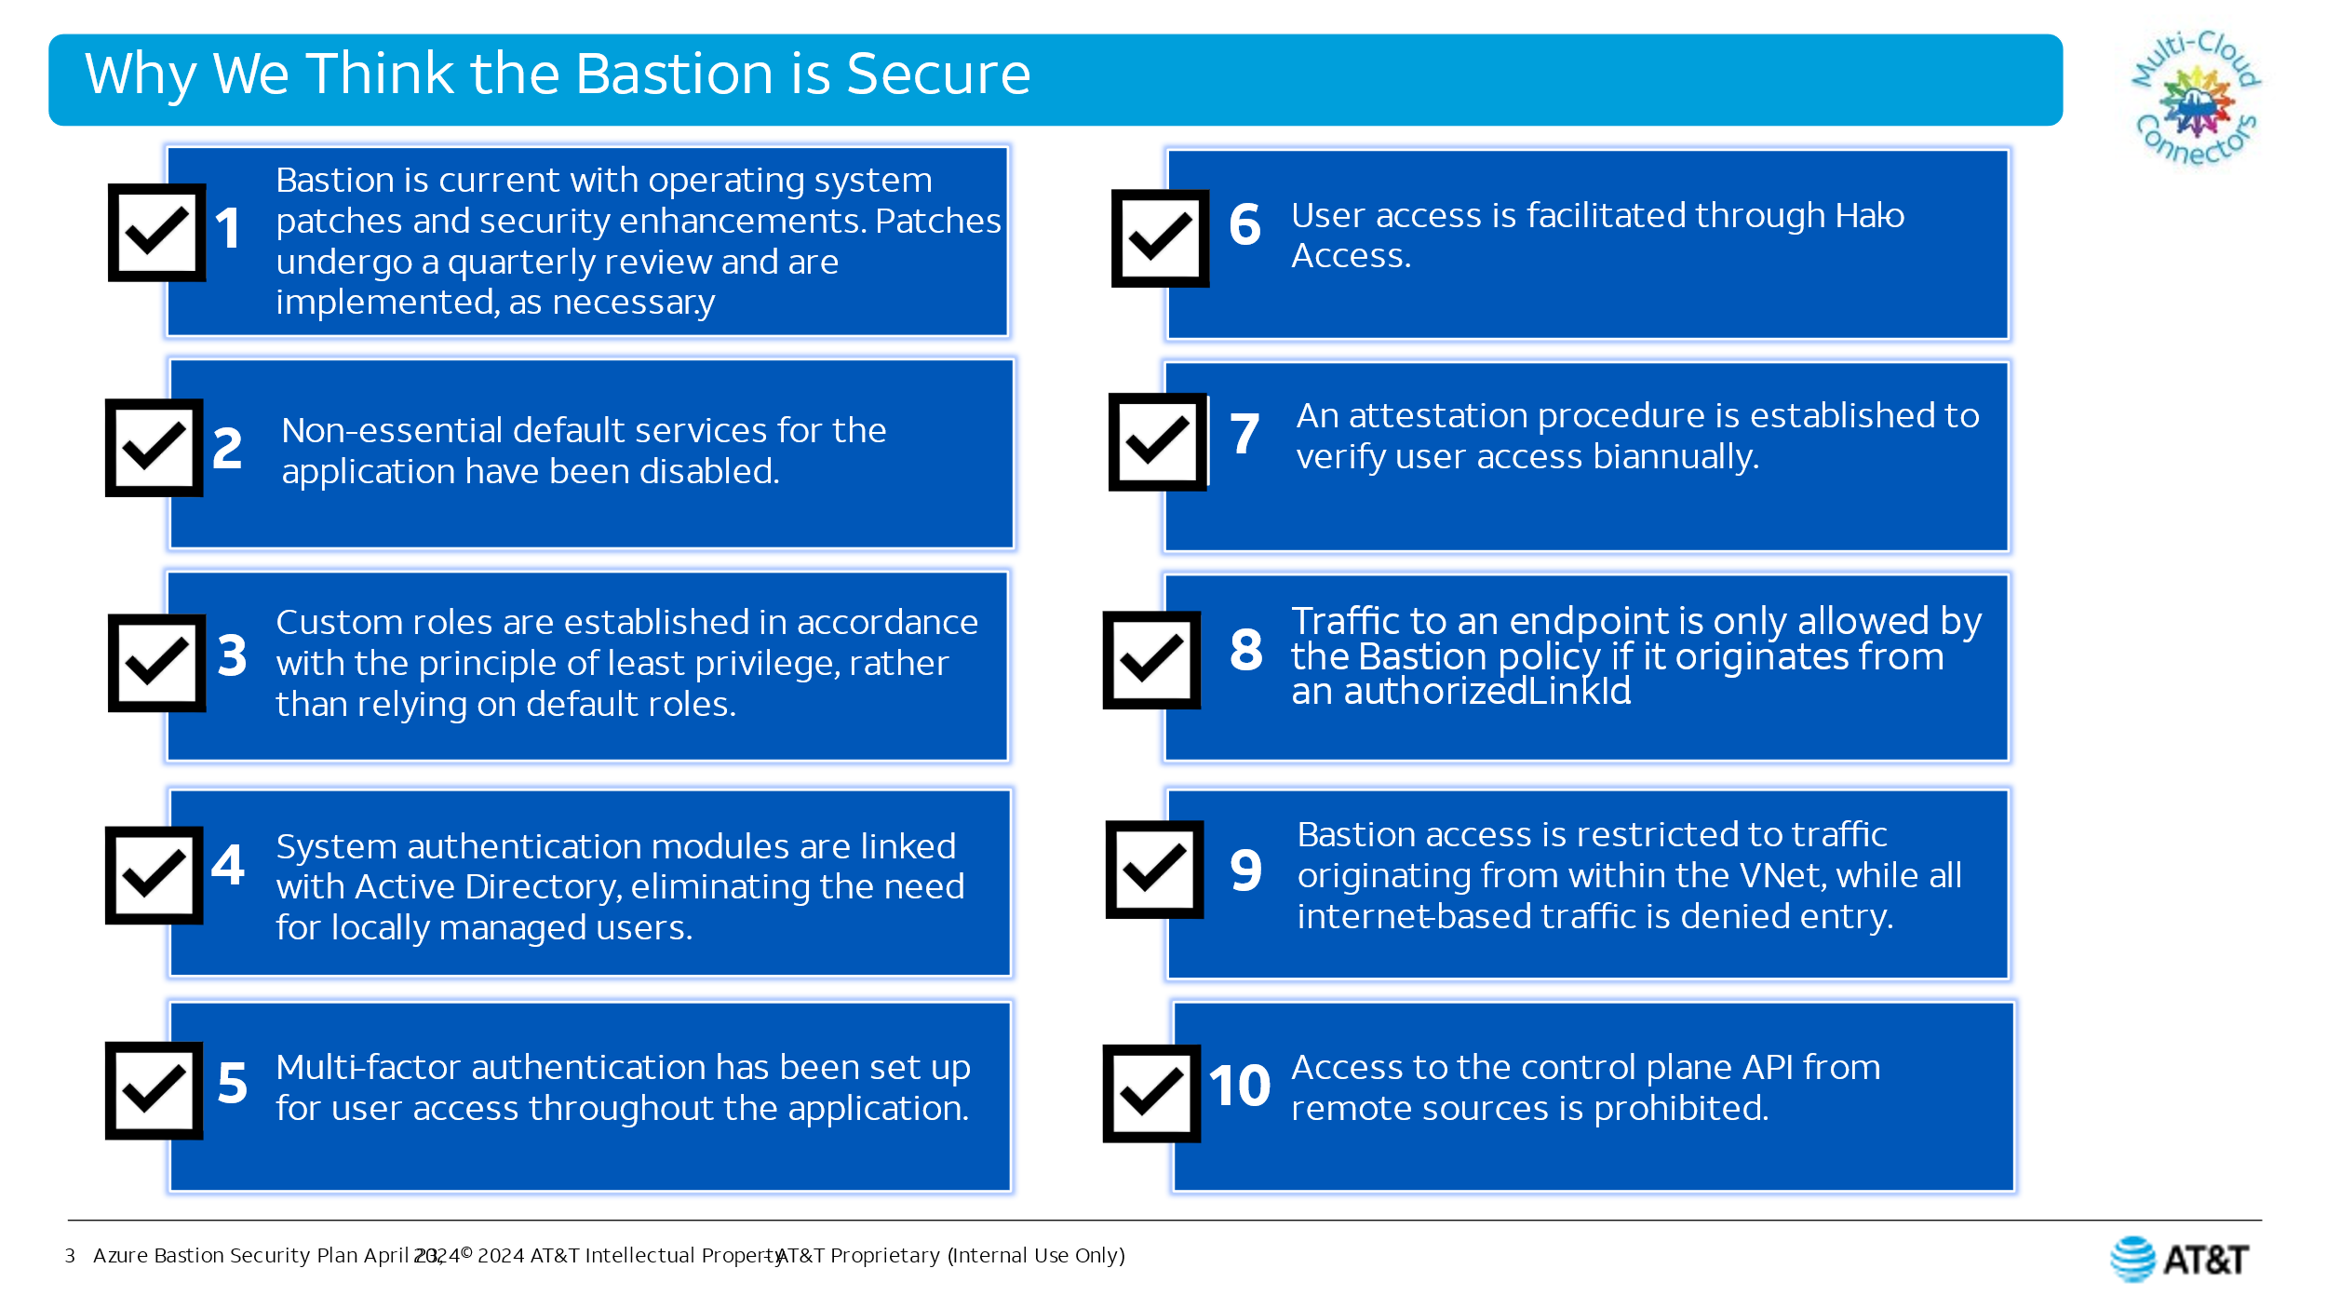 19

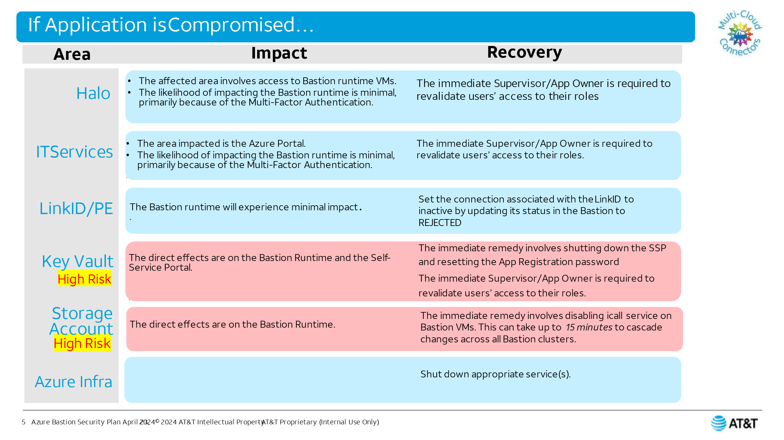 19

Before and after examples: 20

Before 20

After 20

Before 21

After 21

Before 22

After 22

Articles 23

AKS Upgrade 23

RHEL Release 23

SSP Release 24

SSP Release 24

Monitoring Podcast weekly series article 25

Release Notes 26

AWS 26

SSP 27

OCI 28

SharePoint Form Development 29

Source Material to Finished Deliverable Examples: 30

Source Material 30

Deliverable 30

Source Material 31

Deliverable 31

Source Material 32

Deliverable 33

Source Material 34

Deliverable 34

Source Material 35

Deliverable 35

One Pager slides 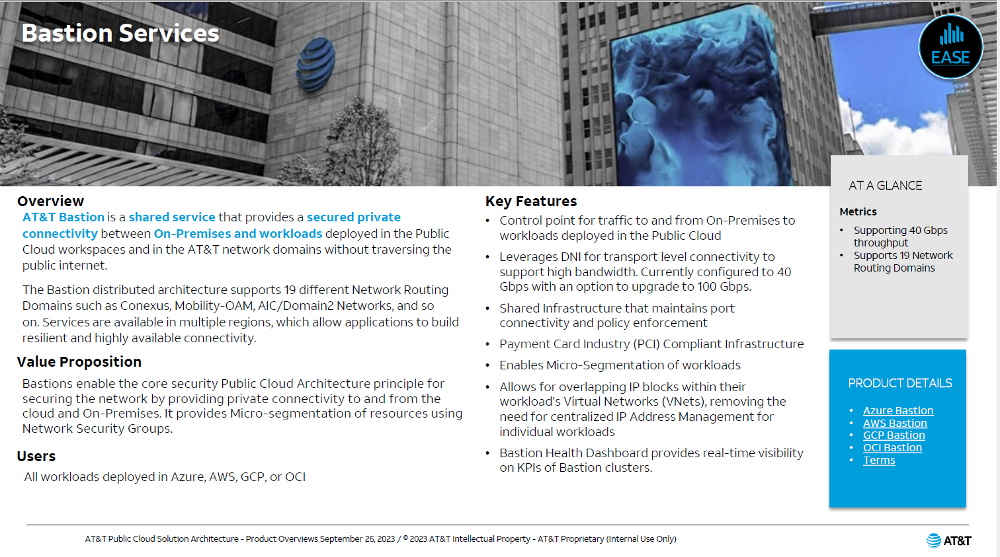 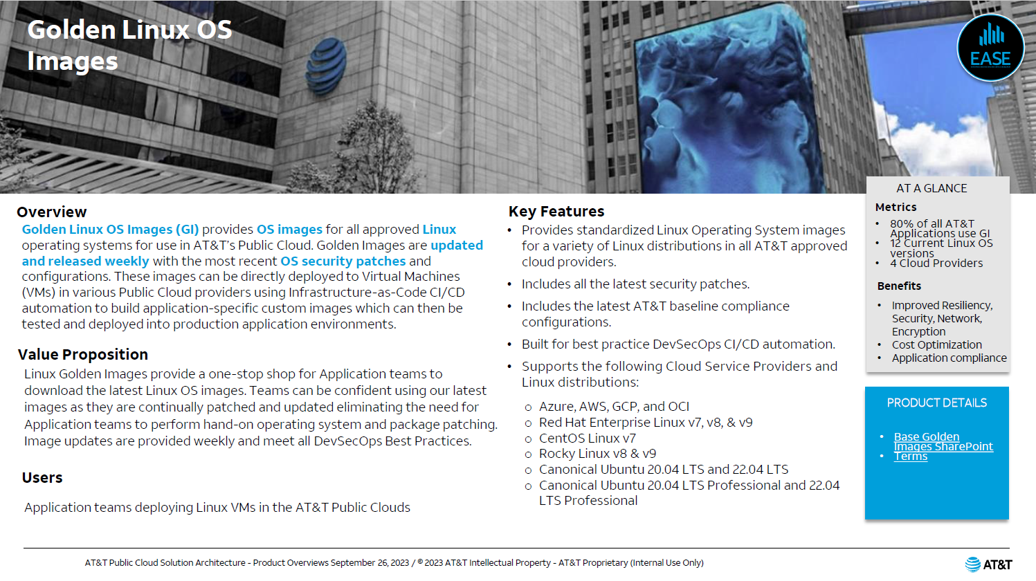

## Two Pager Slides

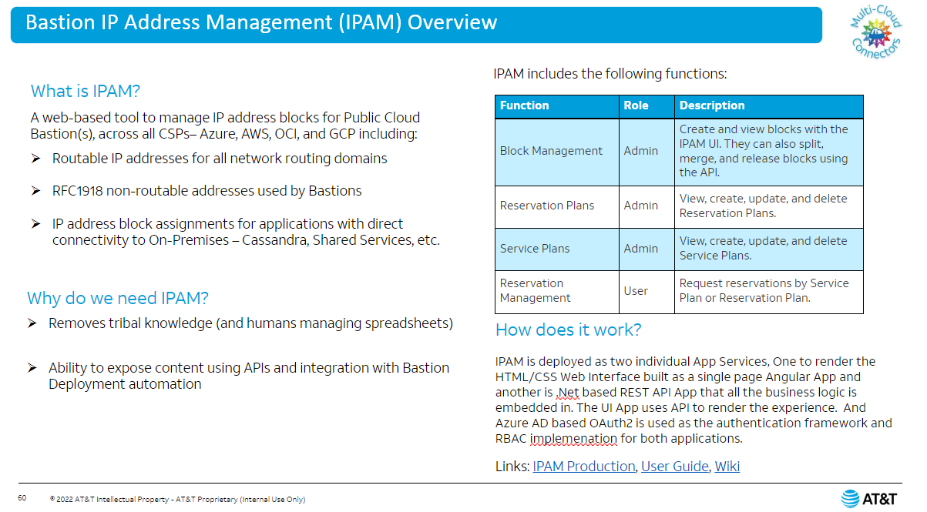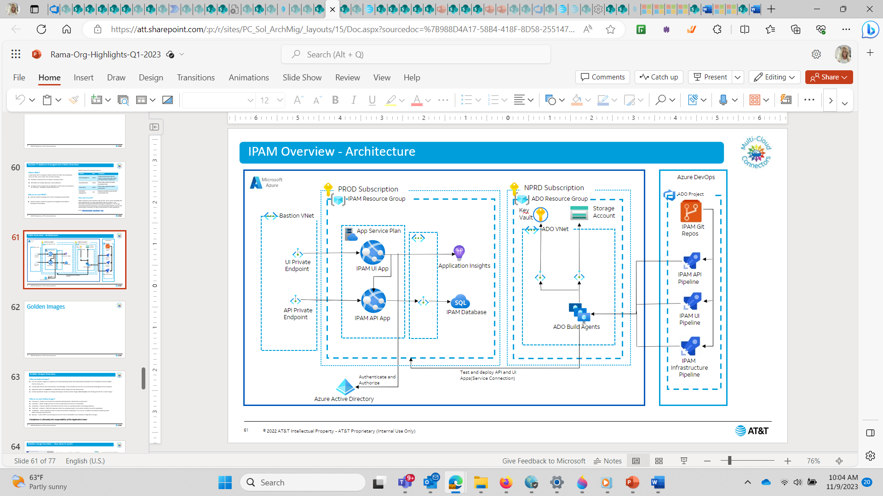

## Architecture Diagrams

**Before** (This is an example of source material):

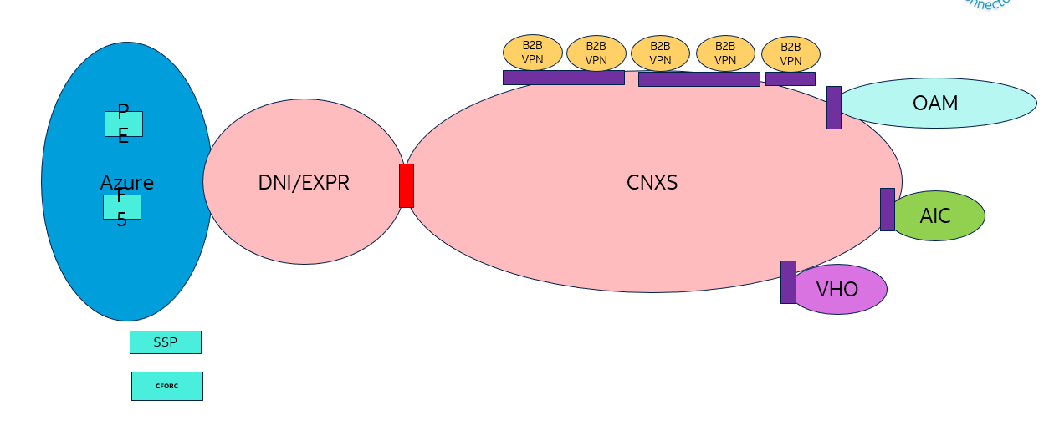

**After**:

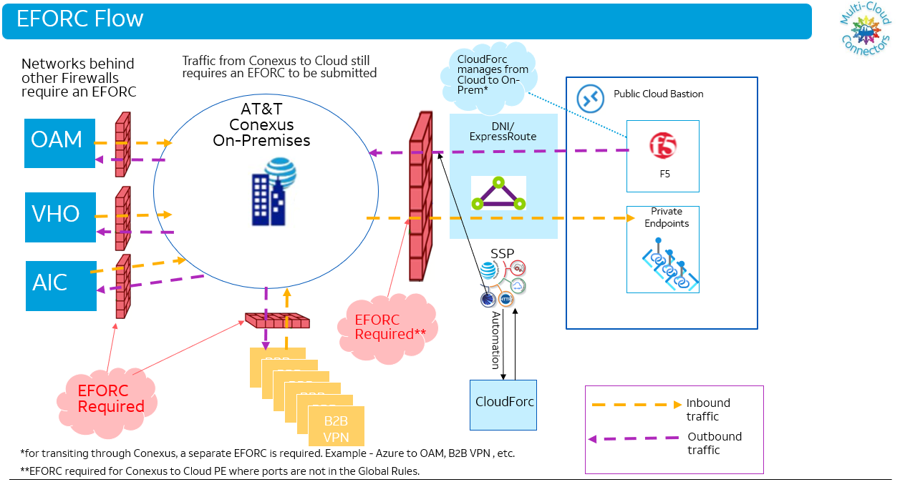

## System Help SharePoint Pages

### Bastion Health Dashboard Guide

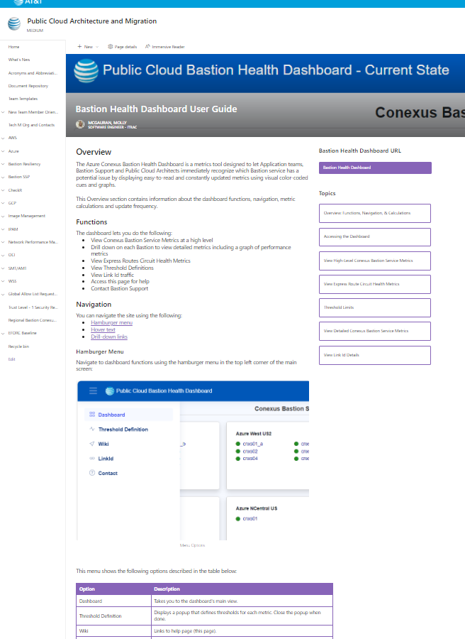

### Knowledge Center

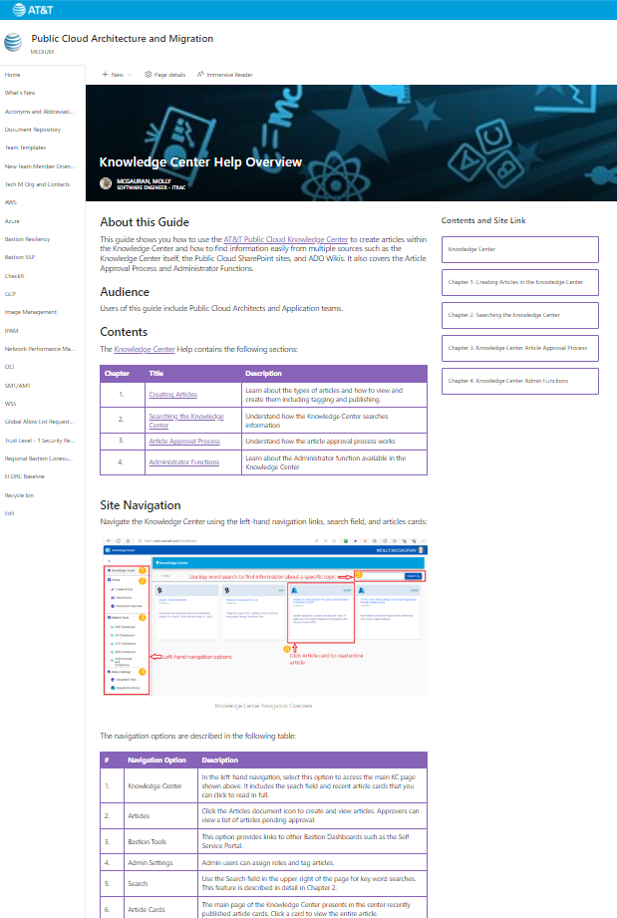

# Site Maps

Implemented Site Maps for each Track’s Documentation Starting with OCI:

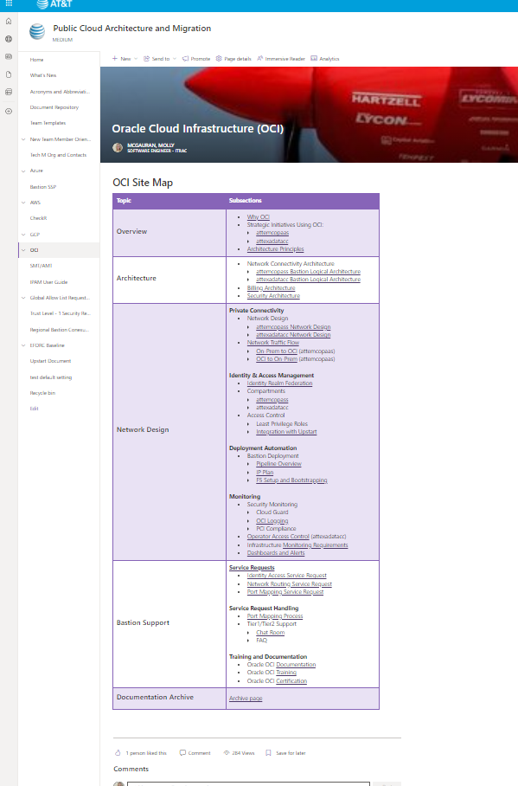

## Overview

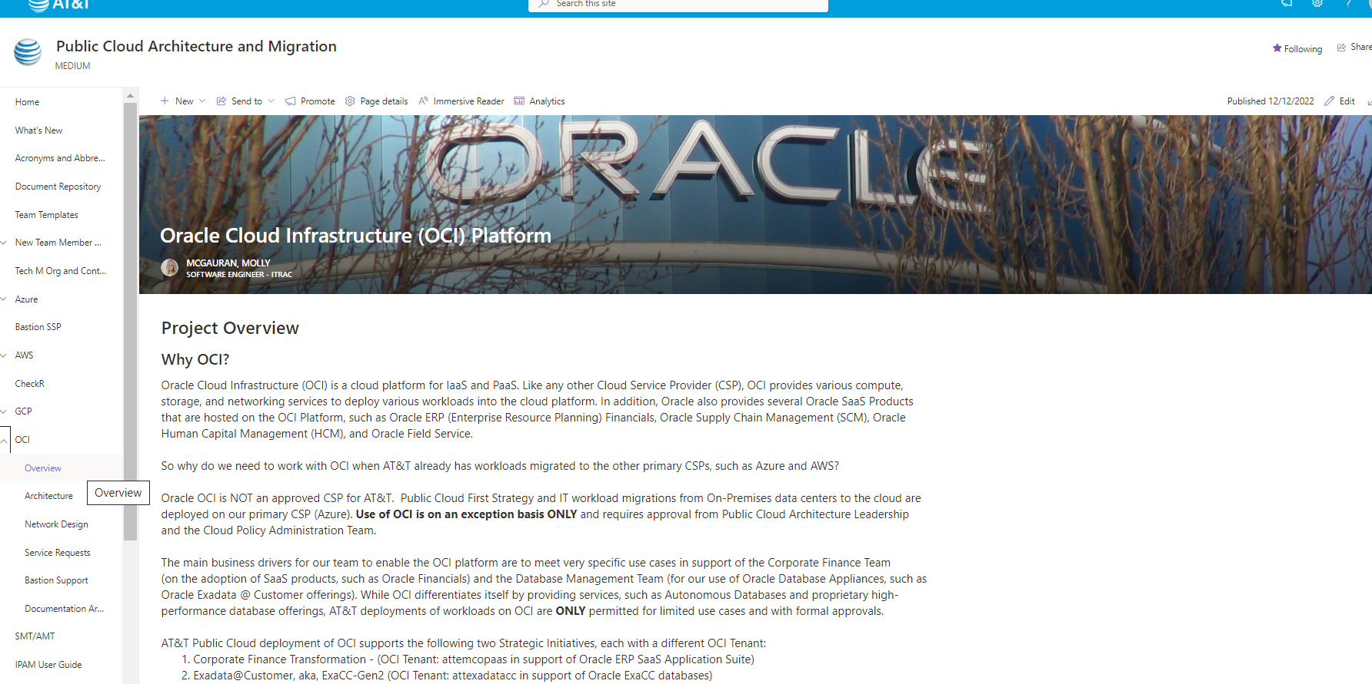

## Pipelines

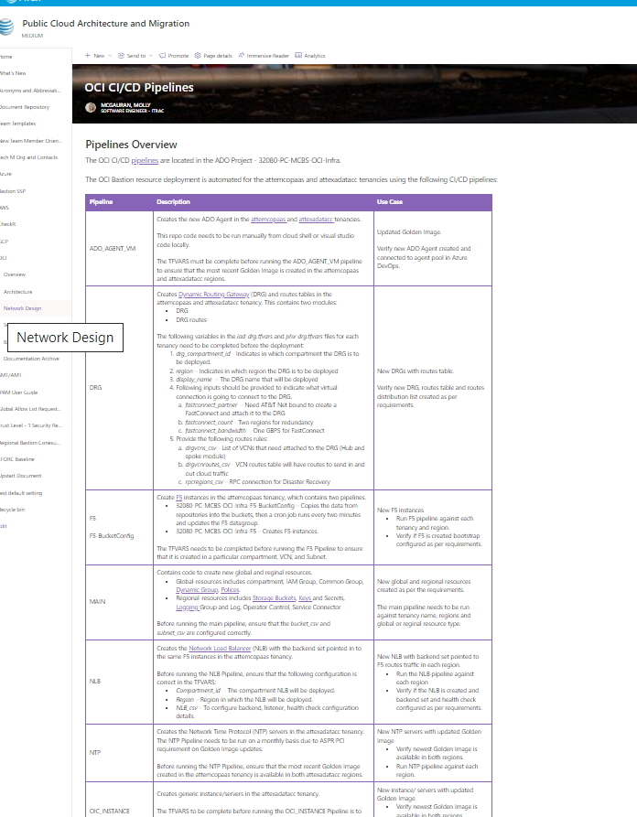

## Dashboards

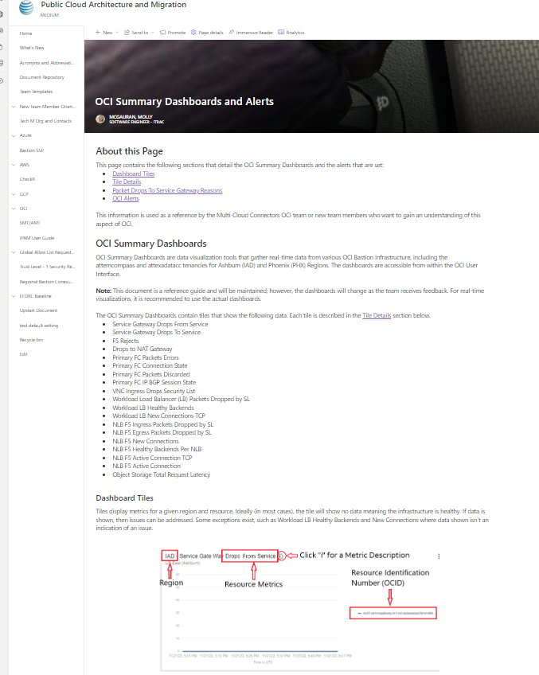

## Dashboards Details

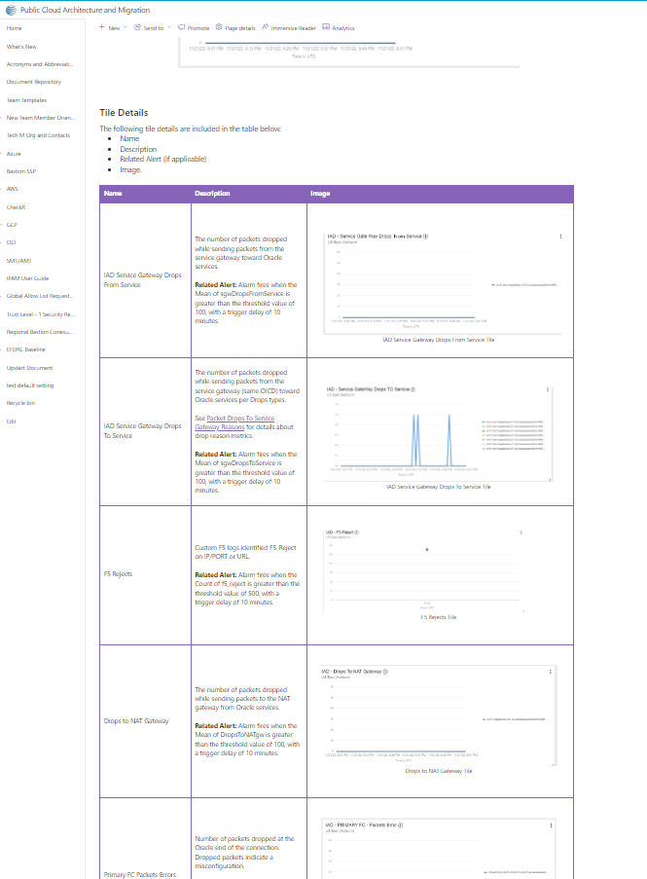

# Process Pages

## AWS Get Started process pages:

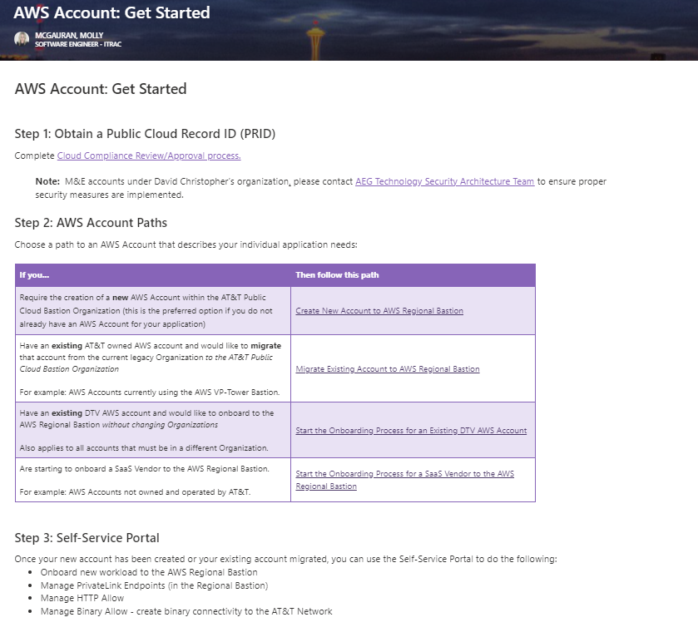

## Support Instructions for AWS

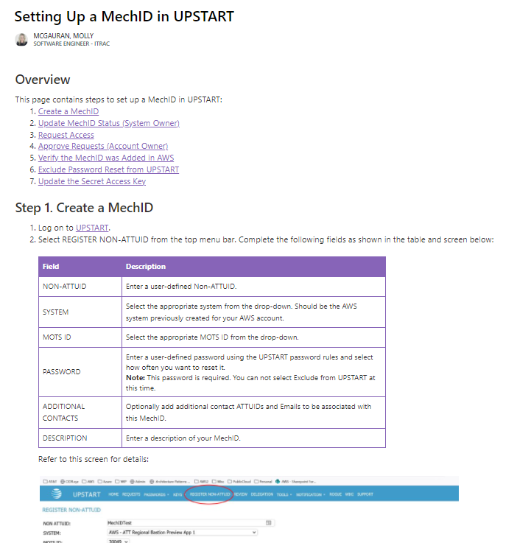

## Migrating AWS Account

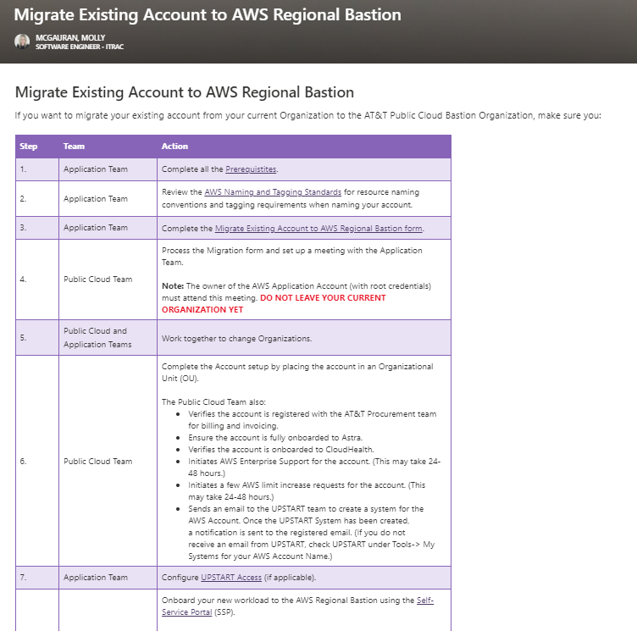

## IPAM

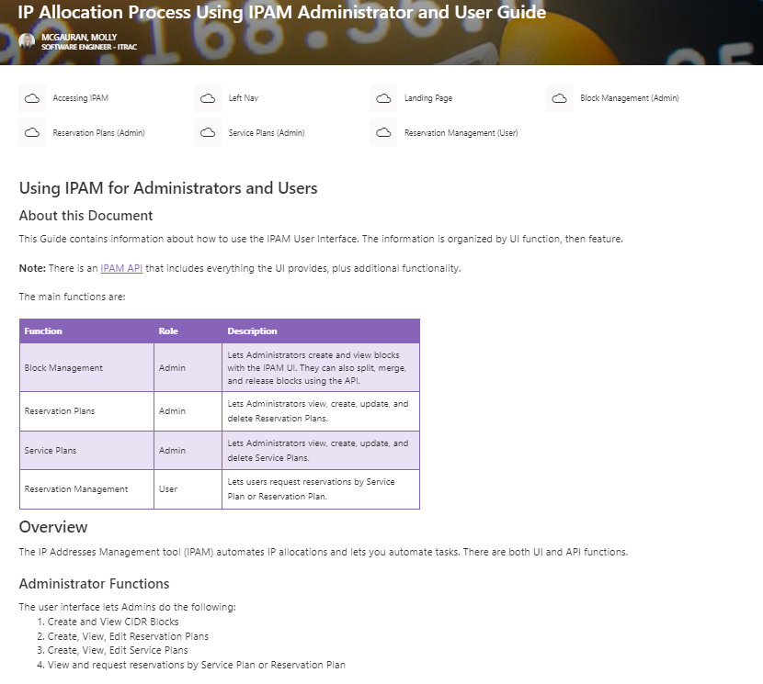

## Onboard New Infosys Team Members

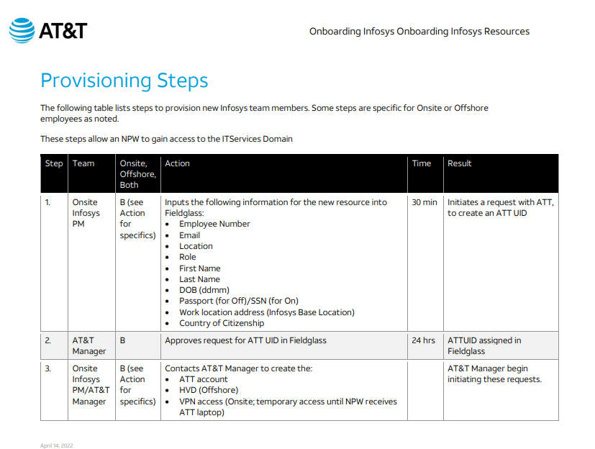

# Decks and Slides

## 

## 

## Before and after examples:

### Before

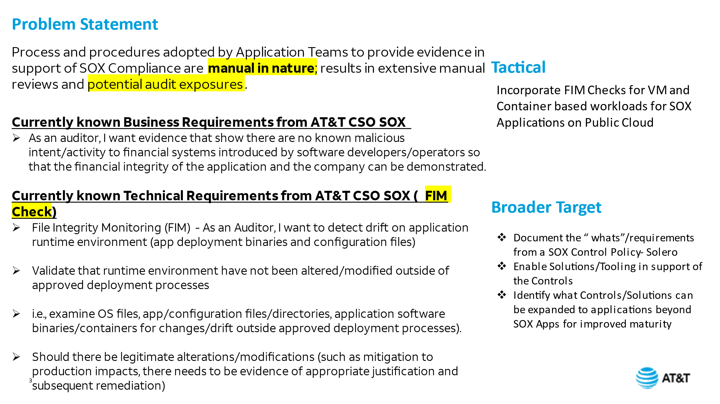

### After

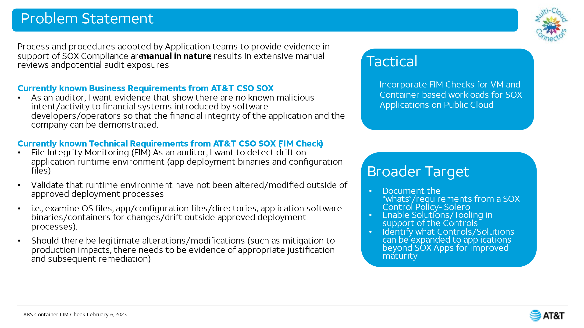

### Before

There were three similar flow charts originally like this one:

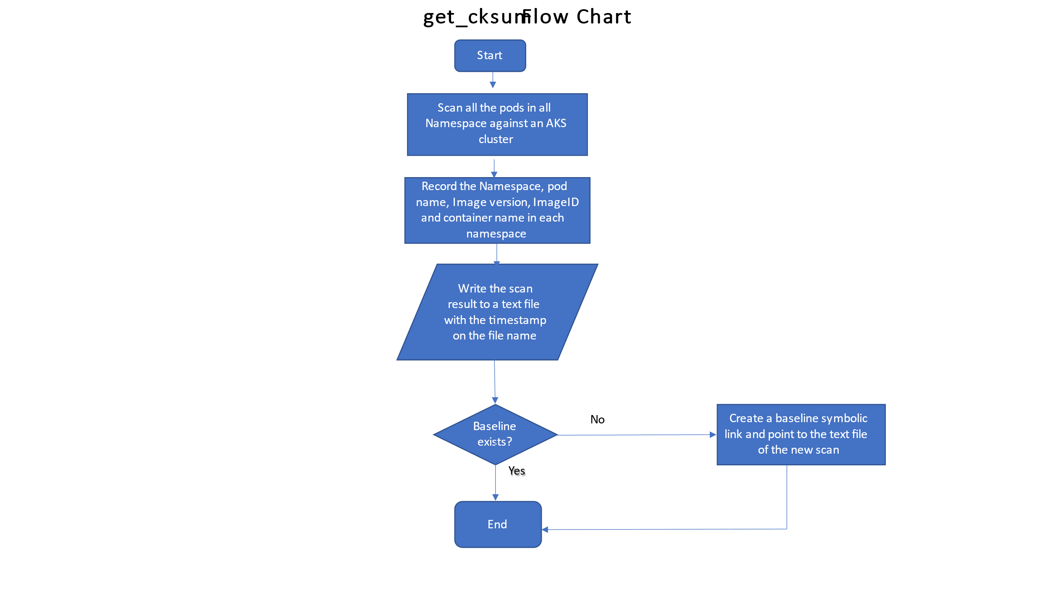

## After

Combined into one slide:

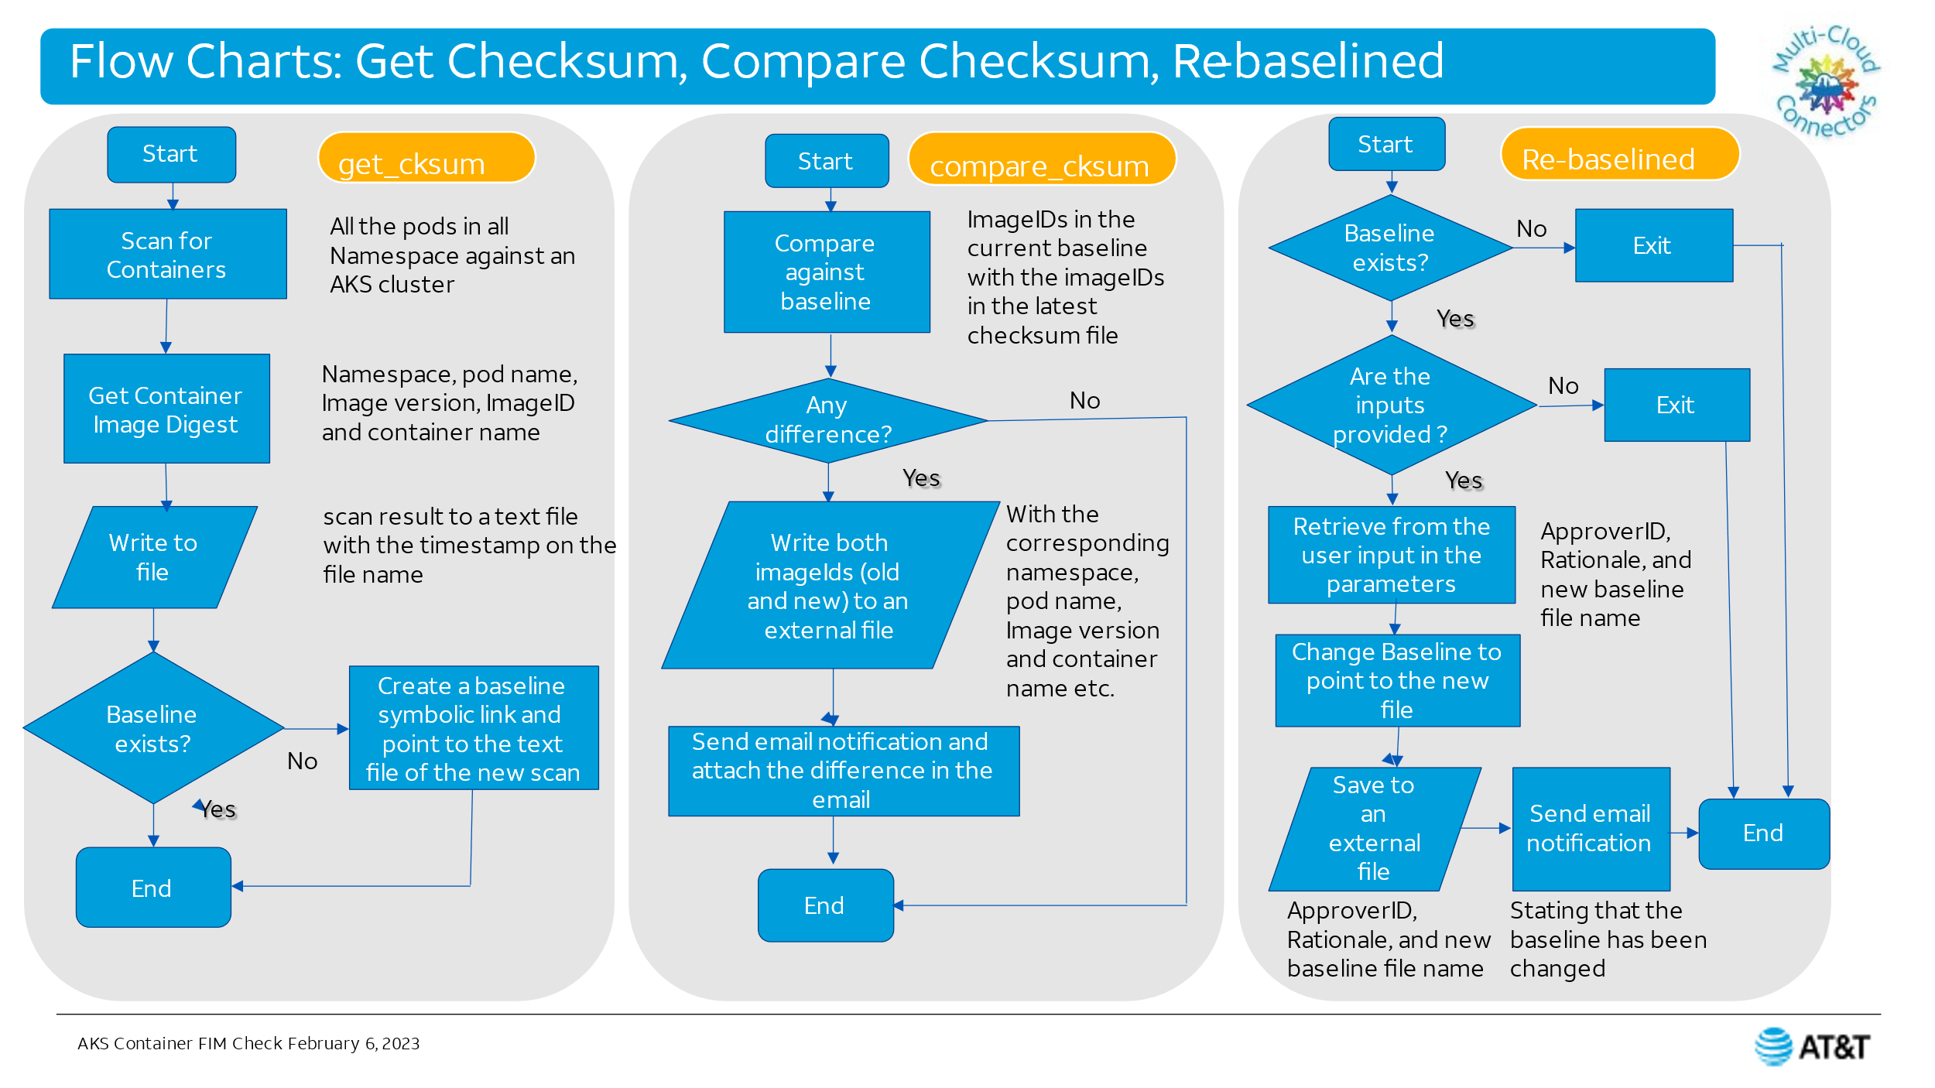

### Before

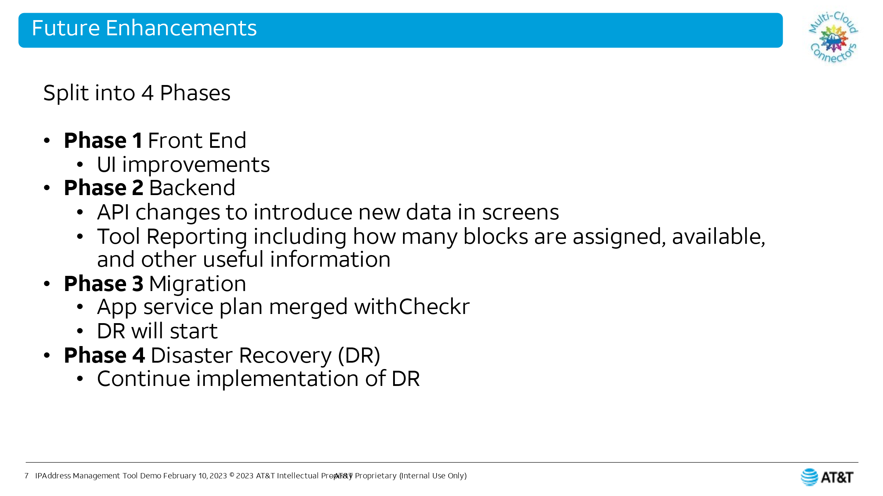

### After

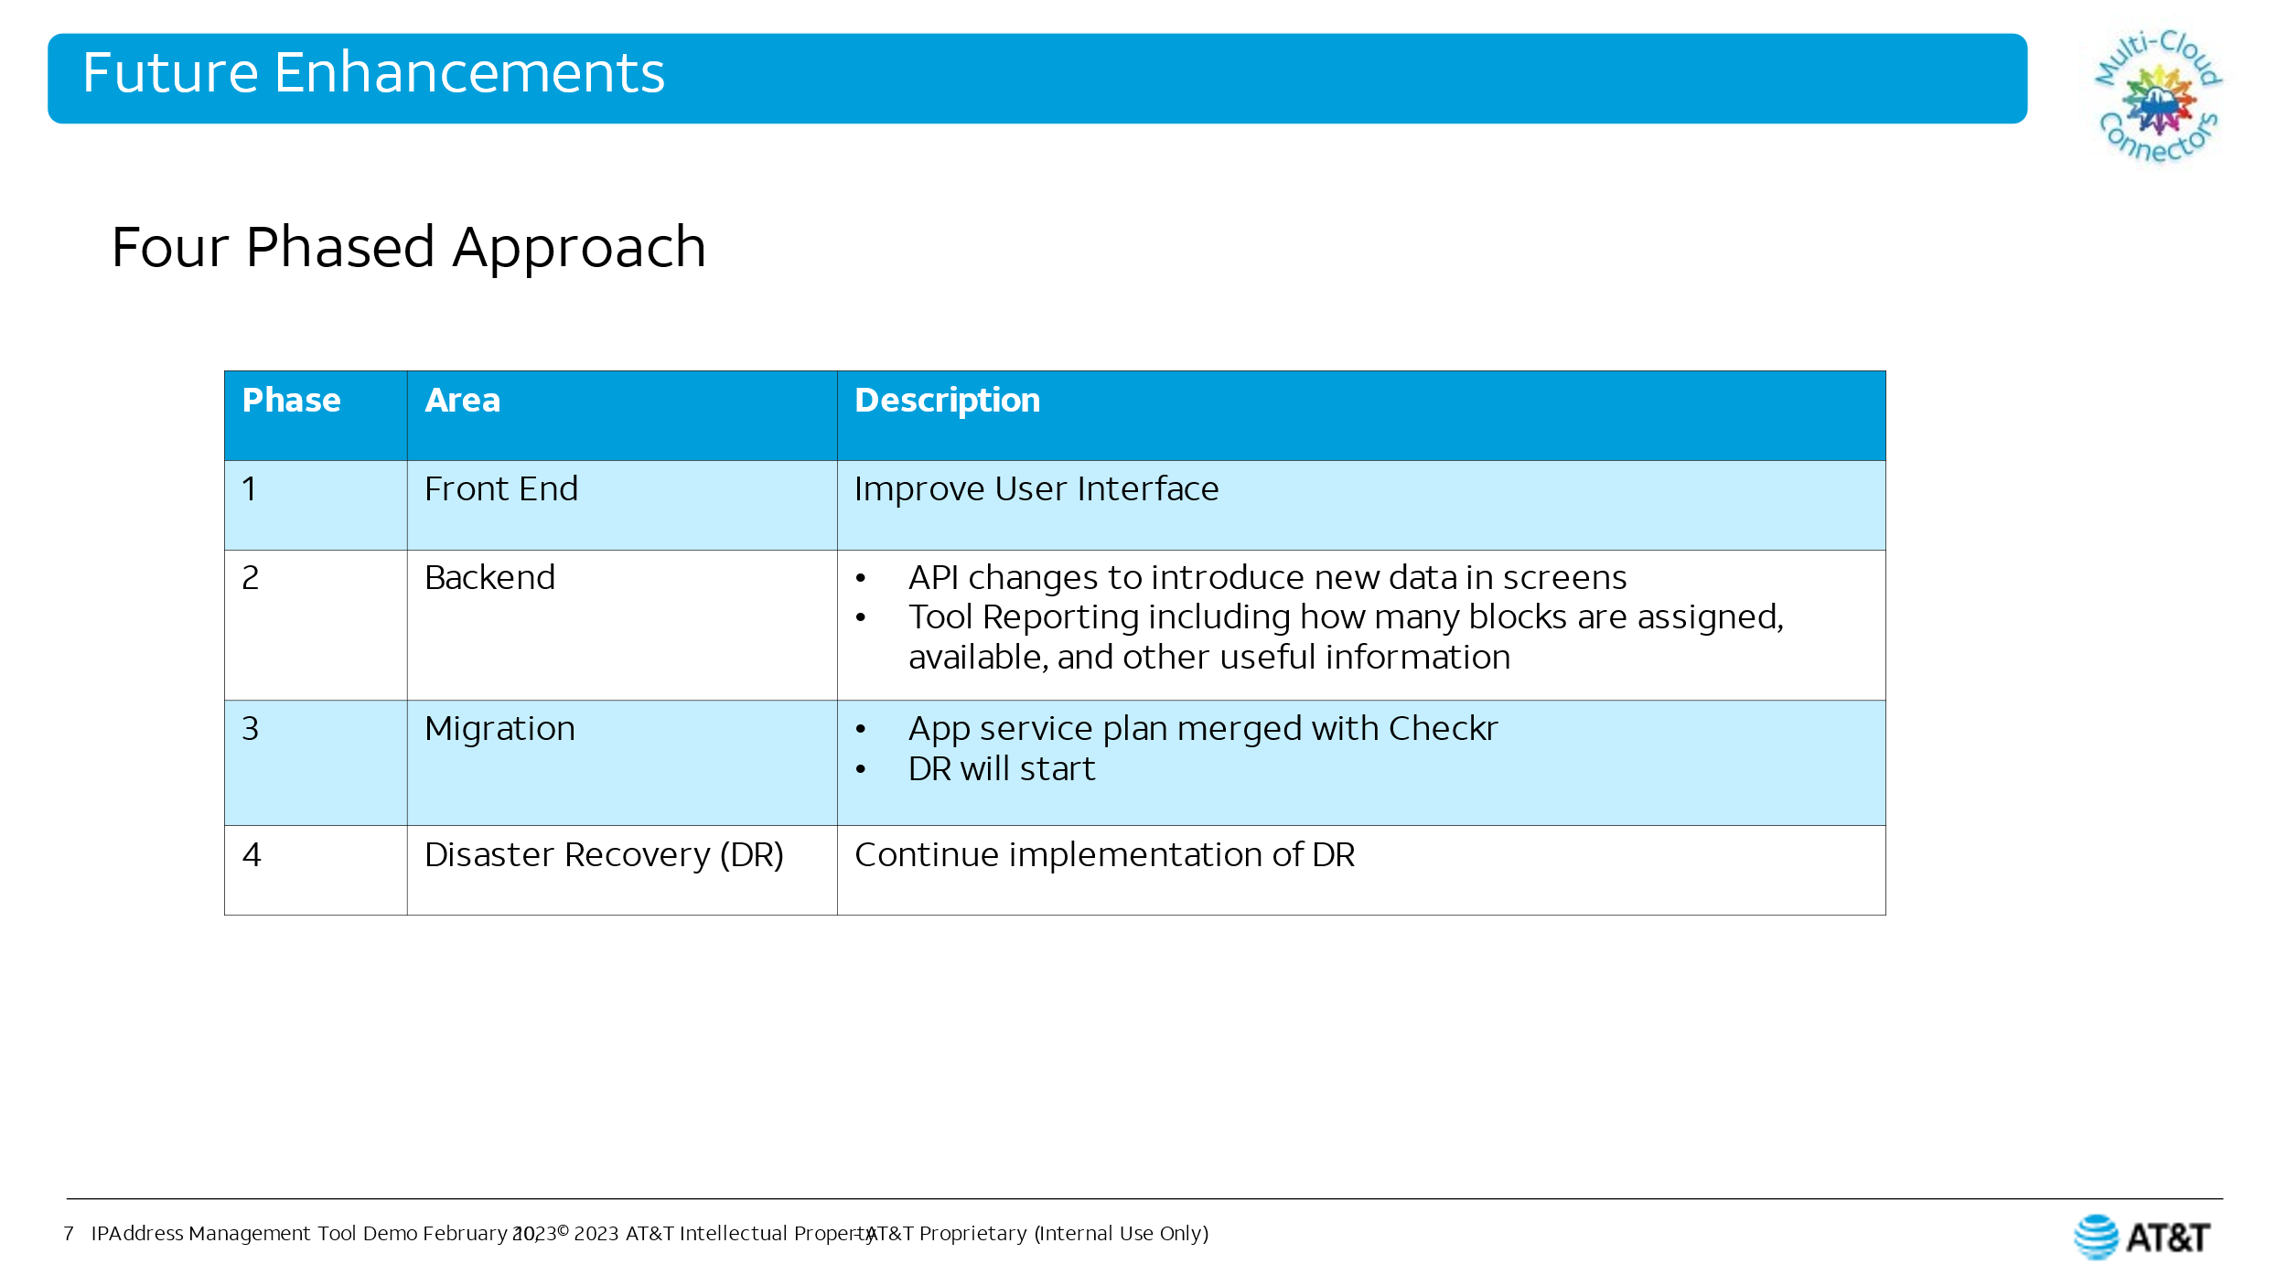

# Articles

## AKS Upgrade

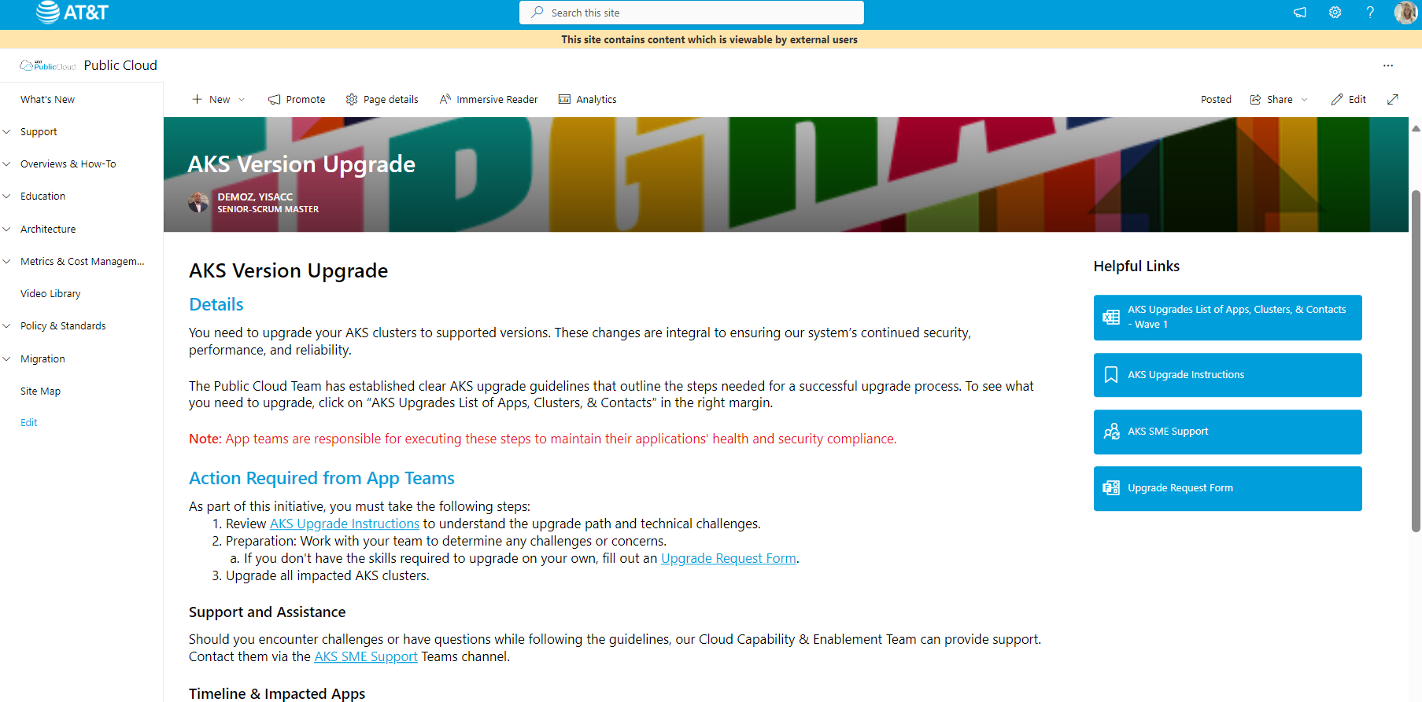

## RHEL Release

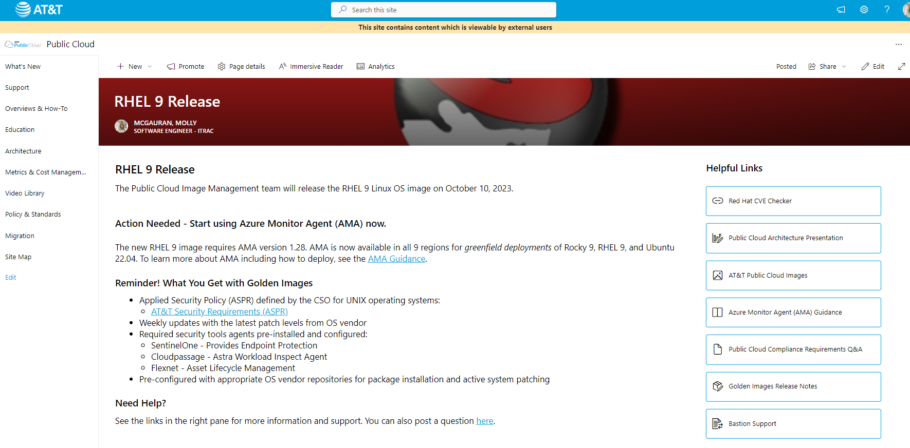

## SSP Release

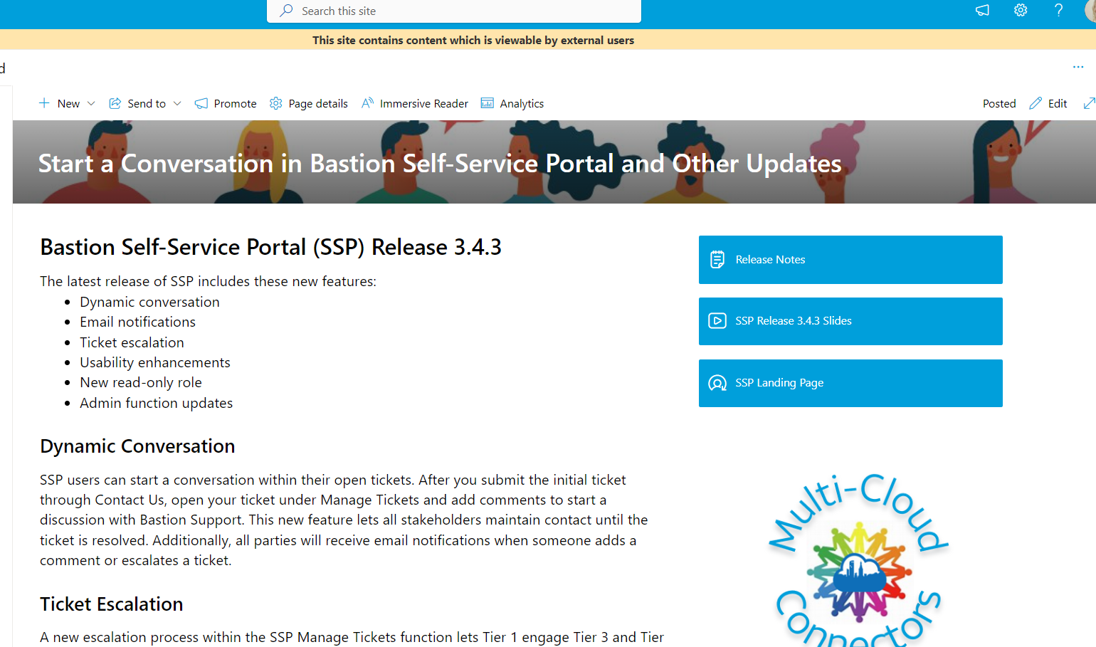

## SSP Release

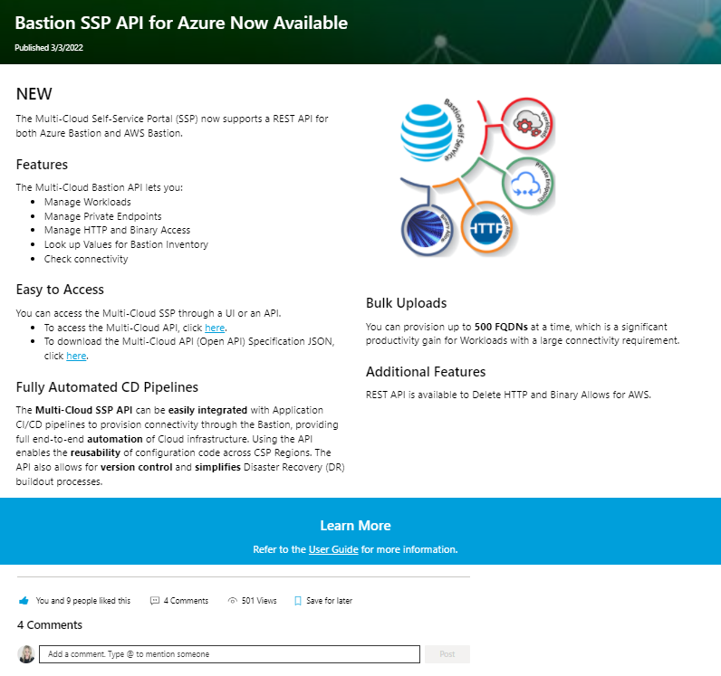

## Monitoring Podcast weekly series article

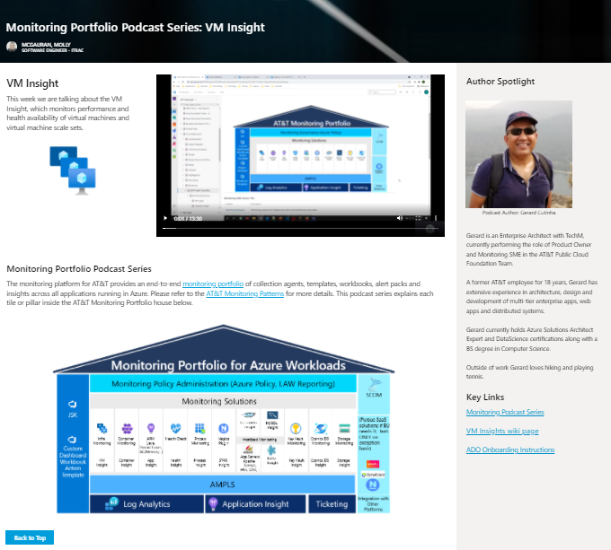

# Release Notes

Publish updates for each project when they deploy to prod.

## AWS

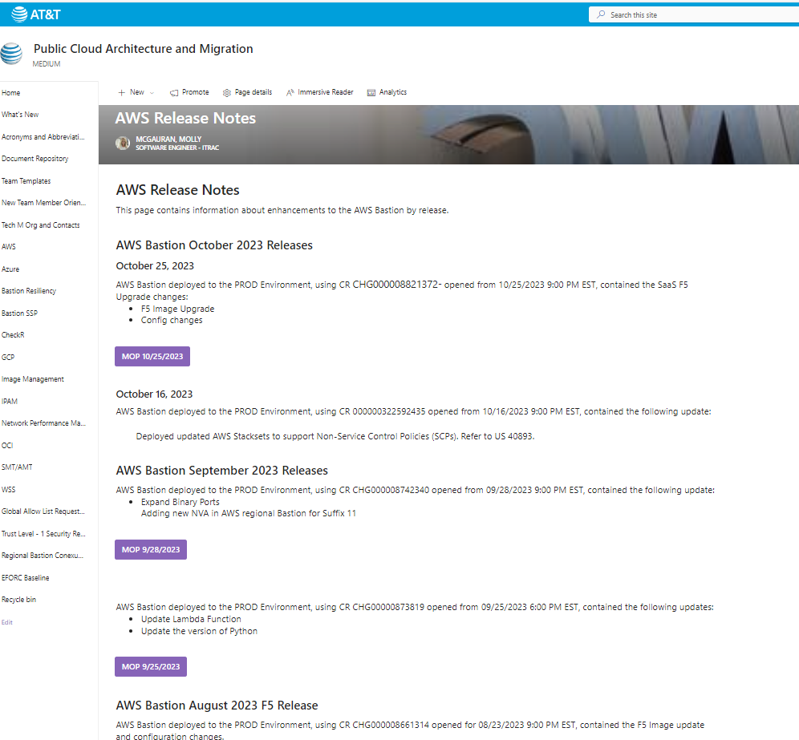

## SSP

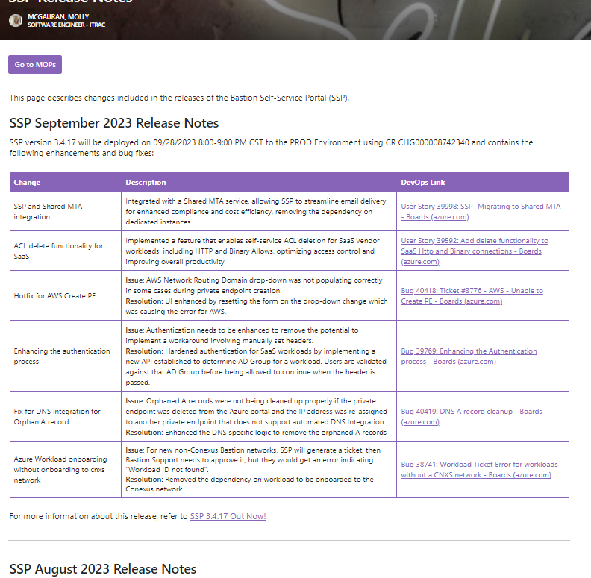

## OCI

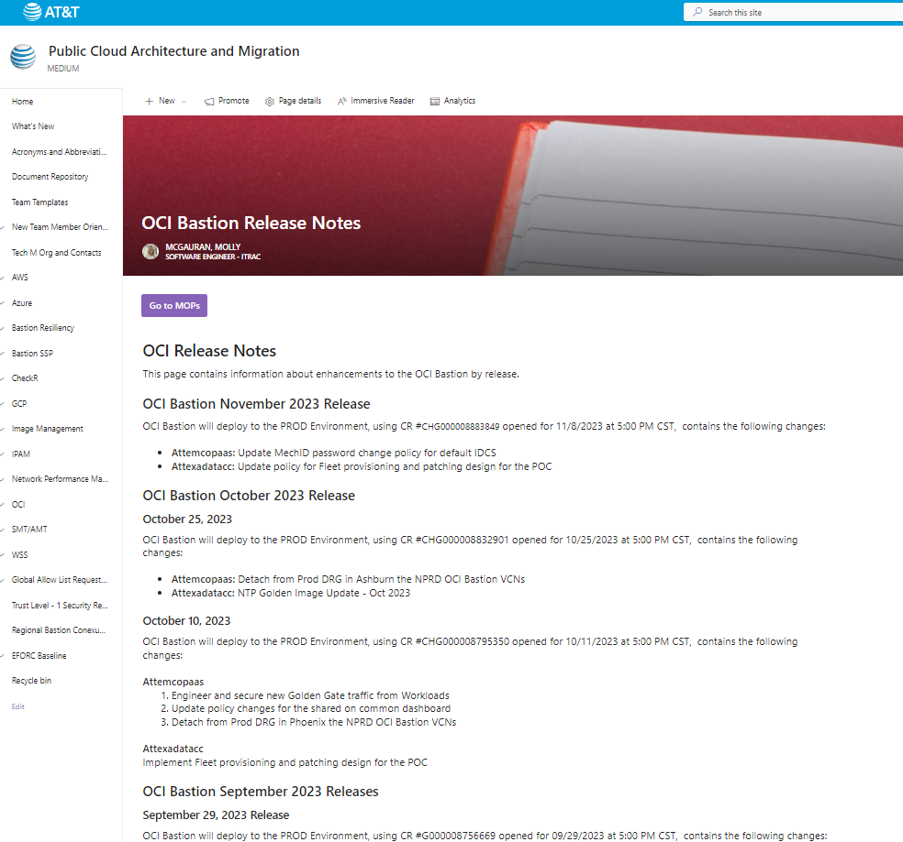

# SharePoint Form Development

Port Mapping Request customized in Power Apps and tied to a Power Automate workflow: Once submitted triggers email notification to implementation team to work request and also sends notice to the user.

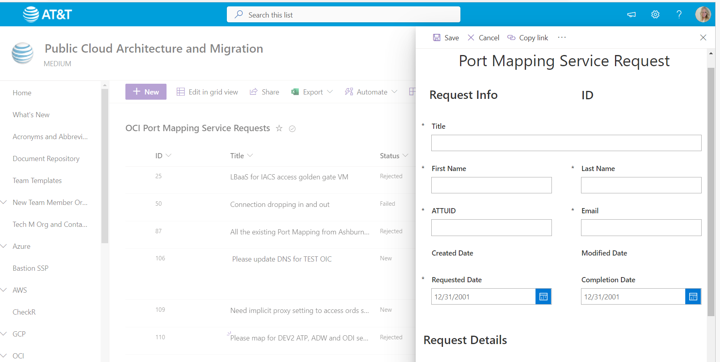

# Source Material to Finished Deliverable Examples:

## Source Material

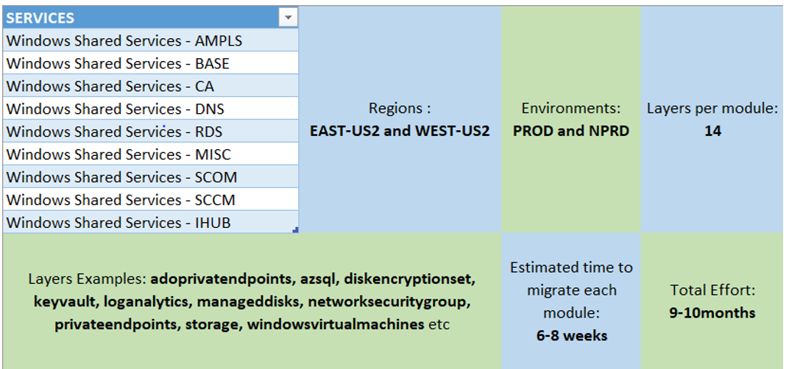

## Deliverable

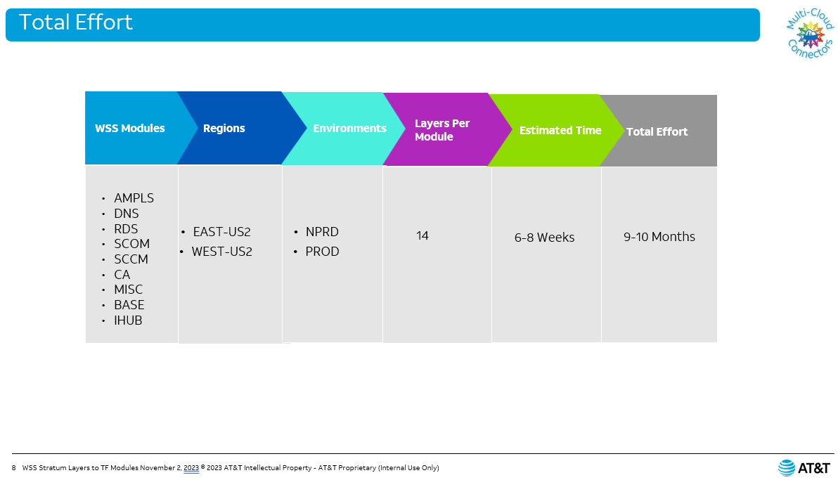

## Source Material

**Step by step:**

* Resources were initially deployed using the old pipelines which are based on the Stratum layers in the WSS-Non Prod Environment(POC-04)
* Now we use the newly created pipelines to run the “terraform import” on the resources deployed though the Stratum layers to get them imported into a new state file(another container for Terraform Modules).
* After importing, the terraform plan shows the deviation from the deployed infra(via stratum) and the modules-states if there are any changes.
* Make sure in the terraform plan, nothing is being impacted on the existing resources.
* However, evaluate the new additions like tag changes and resources that are getting newly created like a null-resource, role-assignments etc.

## Deliverable

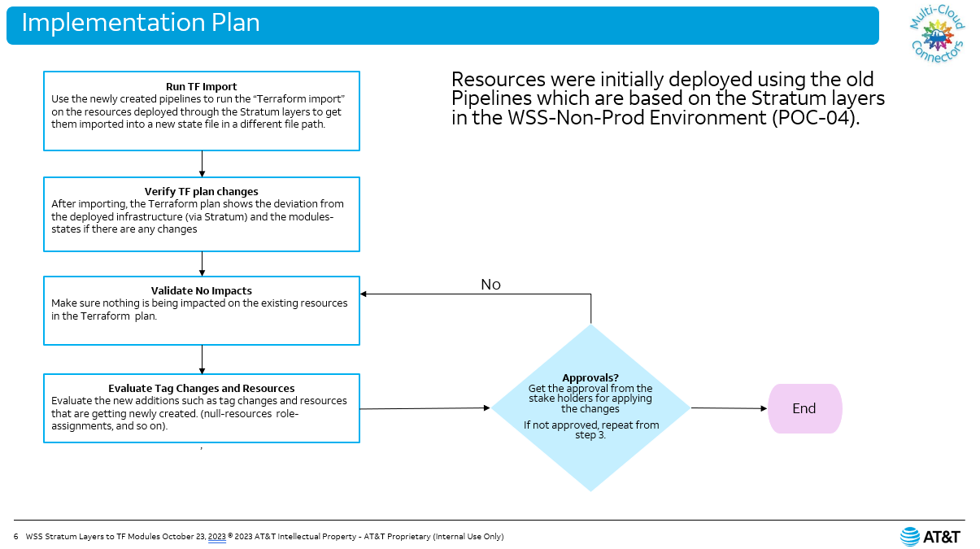

## Source Material

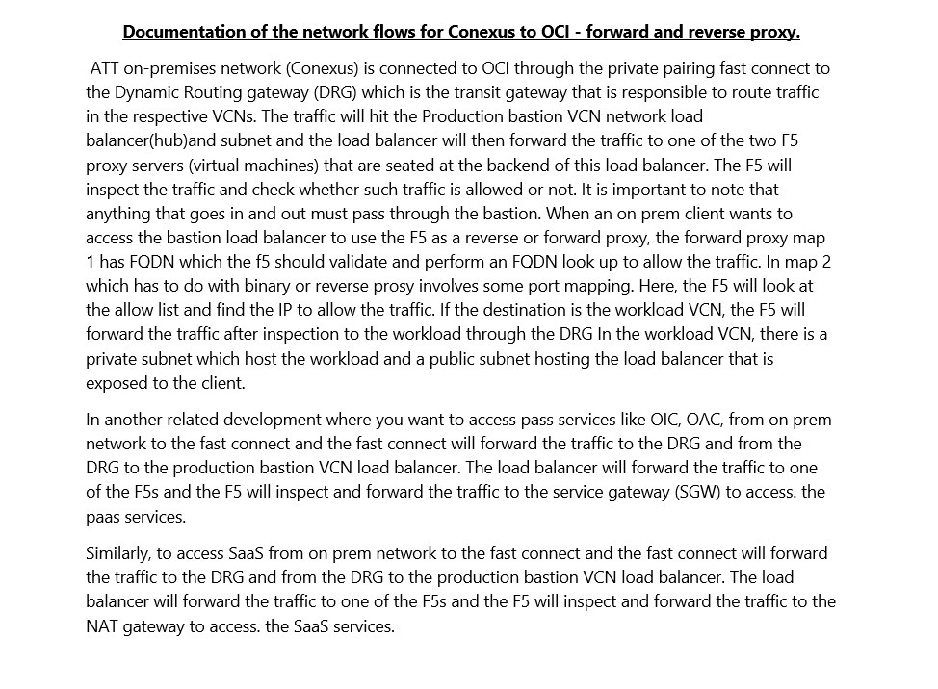

## Deliverable

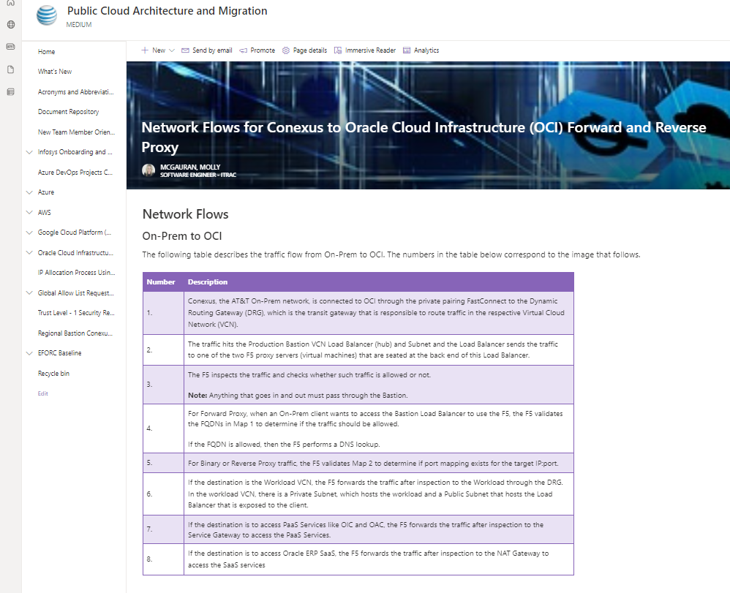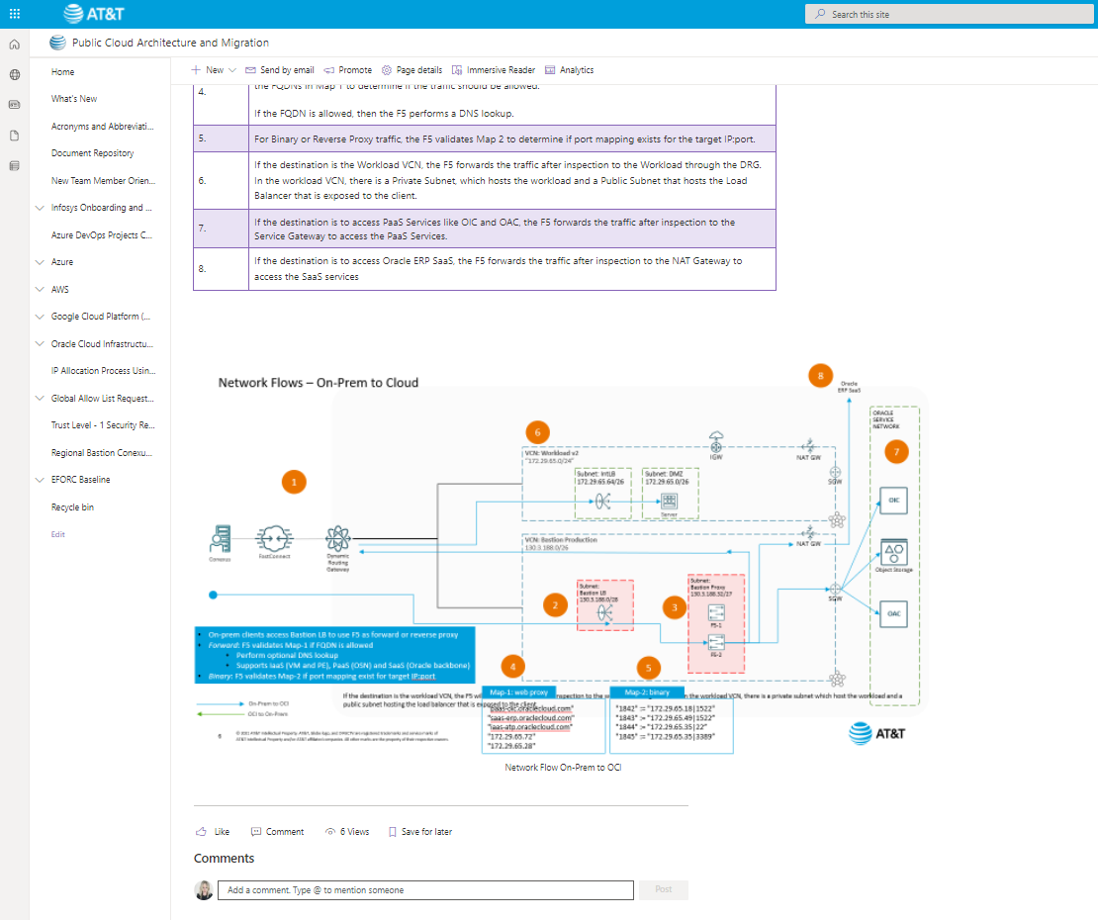

## Source Material

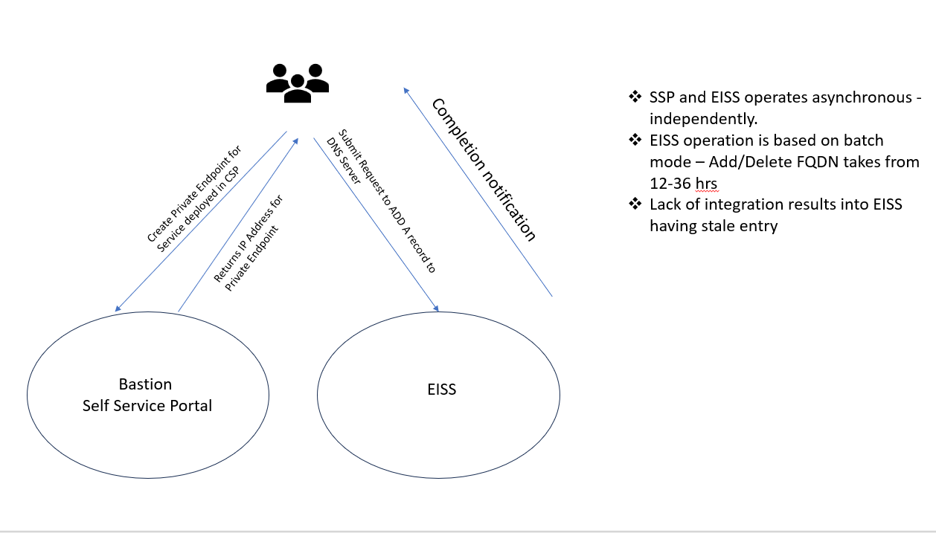

## Deliverable

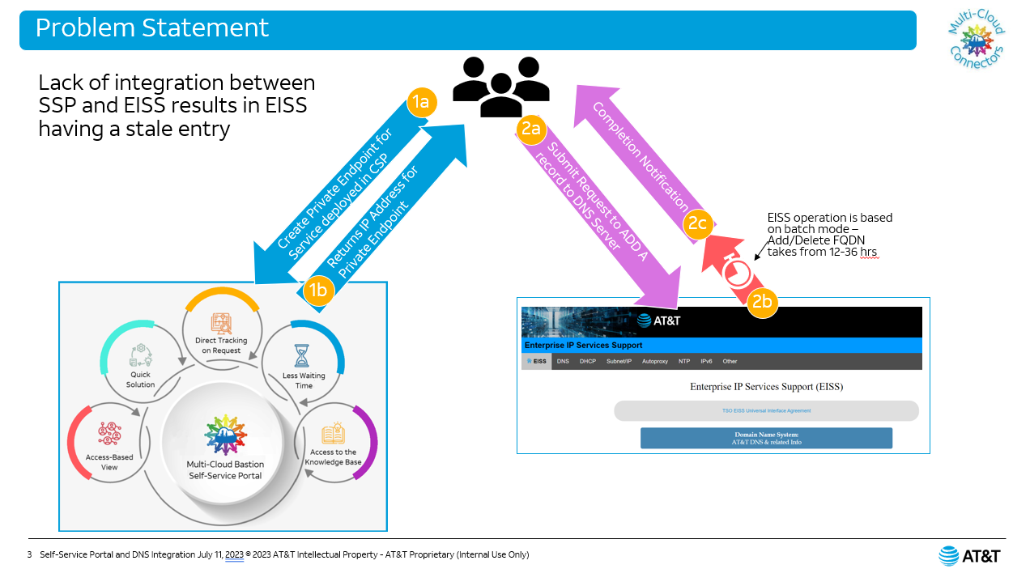

## Source Material

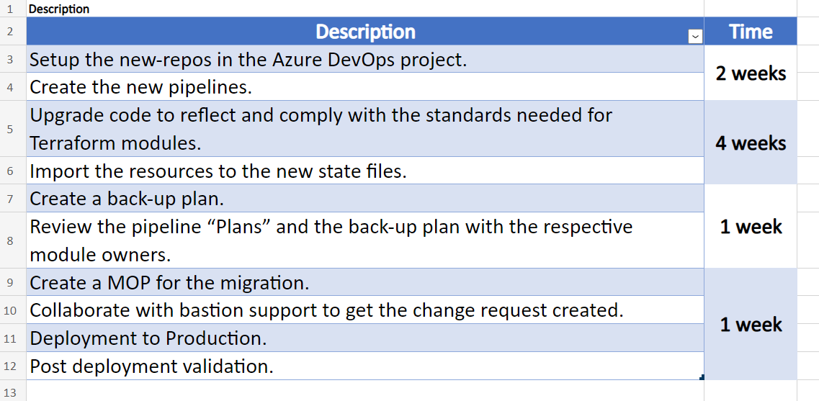

## Deliverable

